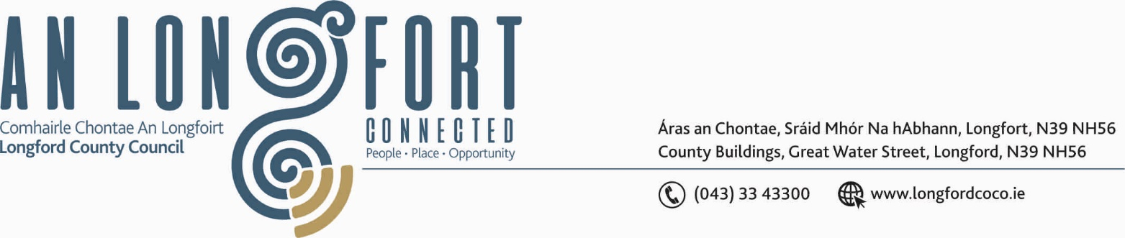
2u Bealtaine 2018.

Chuig: Gach Ball don Chomhairle.

A Chomhairleoir,

Iarrtar ort bheith i láthair ag Cruinniú Míosuil Chomhairle Chontae Longfoirt a tionólfar i Seomra na Comhairle, Aras an Chontae, Longfoirt ar an Chéadaoin, 9u Bealtaine 2018 ag 3.30 p.m. chun gnó a dhéanamh d’réir an Chláir thíos.
You are requested to attend the Monthly Meeting of Longford County Council to be held in the Council Chamber, Aras an Chontae, Great Water Street, Longford, on Wednesday, 9th May 2018 at 3.30 p.m. to transact business, as set out on the Agenda hereunder.

Mise le meas,
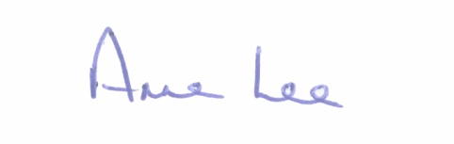

_______________
Anne Lee,
Meetings Administrator.

3.30 p.m. Presentation by Older Persons Council.

3.45 p.m. Launch of “What’s On Guide to County Longford.”

C L A R

Prayer before Meeting.

- Confirmation of Minutes of the Monthly Meeting of Longford County Council held on the
11th April 2018 - copy enclosed.

2. Matters arising from Minutes.

3. To note Chief Executive Orders. (Summary herewith)

4. To note Monthly Management Report - Report to follow.

5. To note adopted Minutes of Corporate Policy Group Meeting held on
14th March 2018 – copy enclosed.

6. Finance & Information Systems.

- To note Public Liability Claims received during April 2018 – Report enclosed.

- Consideration of Annual Financial Statement for Year ended 31st December 2017 -
hard copy by post.

- Consideration of Approval of Additional Expenditure under S104(7) of the Local Government Act 2001.

(d) Consideration of Approval of Loan of €1,200,000 from the HFA to finance approved Housing Loan applications, as authorised by the Housing Acts 1966-1992.

7. Economic and Community Development, Planning, Human Resources & Corporate
Services, Cultural & Recreational Services.

- To note Planning Applications received since April meeting of the Council.

8. General

- Correspondence - copies enclosed.

- Nominations for President of Ireland.

- Correspondence received from Dr. John McHugh, USA, seeking support for his nomination as a candidate for President of Ireland.
- Correspondence received from Marie Goretti Moylan, “Dun na Marc”, 15 Auburn Villas, Athlone, Co. Westmeath seeking support for her nomination as a candidate for President of Ireland.
- Correspondence received from Kevin Sharkey seeking support for his nomination as a candidate for President of Ireland.

(ii) Correspondence received from the Office of the Minister for Children and Youth Affairs regarding Early Years Services rates payments.

- Correspondence received from the Office of the Minister for Agriculture, Food and Marine regarding the fodder situation.

- Correspondence received from Deputy Robert Troy regarding the sale of mortgage accounts by Irish lenders

9. Votes of sympathy.

10. Training -

Consideration of Report from Corporate Policy Group.

